What is bias in machine learning?
Bias is a phenomenon that skews the result of an algorithm in favour or against an idea.
Bias is considered a systematic error that occurs in the machine learning model itself due to incorrect assumptions in the ML process.
Technically, we can define bias as the error between average model prediction and the ground truth. Moreover, it describes how well the model matches the training data set:
- A model with a higher bias would not match the data set closely.
- A low bias model will closely match the training data set.
Characteristics of a high bias model include:
- Failure to capture proper data trends
- Potential towards underfitting
- More generalized/overly simplified
- High error rate

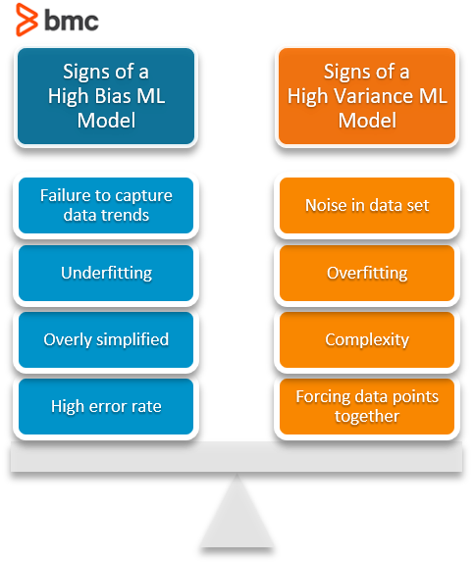

What is variance in machine learning?
Variance refers to the changes in the model when using different portions of the training data set.
Simply stated, variance is the variability in the model prediction—how much the ML function can adjust depending on the given data set. Variance comes from highly complex models with a large number of features.

- Models with high bias will have low variance.
- Models with high variance will have a low bias.
All these contribute to the flexibility of the model. For instance, a model that does not match a data set with a high bias will create an inflexible model with a low variance that results in a suboptimal machine learning model.
Characteristics of a high variance model include:
- Noise in the data set
- Potential towards overfitting
- Complex models
- Trying to put all data points as close as possible

Underfitting & overfitting
The terms underfitting and overfitting refer to how the model fails to match the data. The fitting of a model directly correlates to whether it will return accurate predictions from a given data set.
- Underfitting occurs when the model is unable to match the input data to the target data. This happens when the model is not complex enough to match all the available data and performs poorly with the training dataset.
- Overfitting relates to instances where the model tries to match non-existent data. This occurs when dealing with highly complex models where the model will match almost all the given data points and perform well in training datasets. However, the model would not be able to generalize the data point in the test data set to predict the outcome accurately.

Bias vs variance: A trade-off
Bias and variance are inversely connected. It is impossible to have an ML model with a low bias and a low variance.
When a data engineer modifies the ML algorithm to better fit a given data set, it will lead to low bias—but it will increase variance. This way, the model will fit with the data set while increasing the chances of inaccurate predictions.
The same applies when creating a low variance model with a higher bias. While it will reduce the risk of inaccurate predictions, the model will not properly match the data set.
It’s a delicate balance between these bias and variance. Importantly, however, having a higher variance does not indicate a bad ML algorithm. Machine learning algorithms should be able to handle some variance.
We can tackle the trade-off in multiple ways…
Increasing the complexity of the model to count for bias and variance, thus decreasing the overall bias while increasing the variance to an acceptable level. This aligns the model with the training dataset without incurring significant variance errors.
Increasing the training data set can also help to balance this trade-off, to some extent. This is the preferred method when dealing with overfitting models. Furthermore, this allows users to increase the complexity without variance errors that pollute the model as with a large data set.
A large data set offers more data points for the algorithm to generalize data easily. However, the major issue with increasing the trading data set is that underfitting or low bias models are not that sensitive to the training data set. Therefore, increasing data is the preferred solution when it comes to dealing with high variance and high bias models.

This table lists common algorithms and their expected behavior regarding bias and variance:
Algorithm | Bias | Variance
Linear Regression | High Bias | Less Variance
Decision Tree | Low Bias | High Variance
Bagging | Low Bias | High Variance (Less than Decision Tree)
Random Forest | Low Bias | High Variance (Less than Decision Tree and Bagging)

Mathematically
Let the variable we are trying to predict as Y and other covariates as X. We assume there is a relationship between the two such that
Y=f(X) + e
Where e is the error term and it’s normally distributed with a mean of 0.
We will make a model f^(X) of f(X) using linear regression or any other modelling technique.
So the expected squared error at a point x is
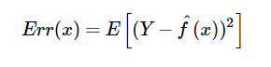
The Err(x) can be further decomposed as
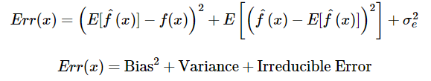
Err(x) is the sum of Bias², variance and the irreducible error.
Irreducible error is the error that can’t be reduced by creating good models. It is a measure of the amount of noise in our data. Here it is important to understand that no matter how good we make our model, our data will have certain amount of noise or irreducible error that cannot be removed.
Bias and variance using bulls-eye diagram
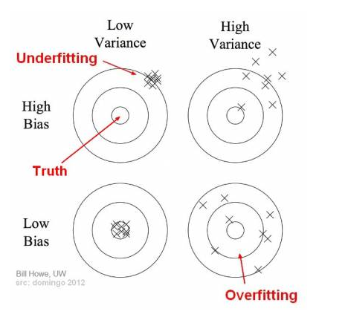
In the above diagram, center of the target is a model that perfectly predicts correct values. As we move away from the bulls-eye our predictions become get worse and worse. We can repeat our process of model building to get separate hits on the target.
In supervised learning, underfitting happens when a model unable to capture the underlying pattern of the data. These models usually have high bias and low variance. It happens when we have very less amount of data to build an accurate model or when we try to build a linear model with a nonlinear data. Also, these kind of models are very simple to capture the complex patterns in data like Linear and logistic regression.
In supervised learning, overfitting happens when our model captures the noise along with the underlying pattern in data. It happens when we train our model a lot over noisy dataset. These models have low bias and high variance. These models are very complex like Decision trees which are prone to overfitting.
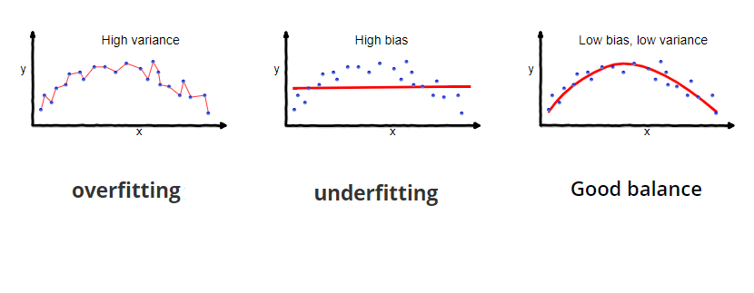

What is Bias Variance Tradeoff?
If our model is too simple and has very few parameters then it may have high bias and low variance. On the other hand if our model has large number of parameters then it’s going to have high variance and low bias. So we need to find the right/good balance without overfitting and underfitting the data.
This tradeoff in complexity is why there is a tradeoff between bias and variance. An algorithm can’t be more complex and less complex at the same time.
Total Error
To build a good model, we need to find a good balance between bias and variance such that it minimizes the total error.
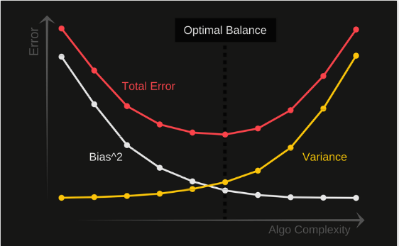
An optimal balance of bias and variance would never overfit or underfit the model.

What is Regularization in Machine Learning?
Regularization refers to techniques that are used to calibrate machine learning models in order to minimize the adjusted loss function and prevent overfitting or underfitting.
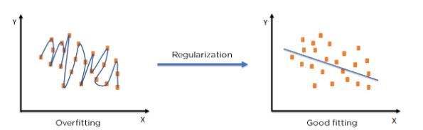
Using Regularization, we can fit our machine learning model appropriately on a given test set and hence reduce the errors in it.

Regularization Techniques
There are two main types of regularization techniques: Ridge Regularization and Lasso Regularization.
